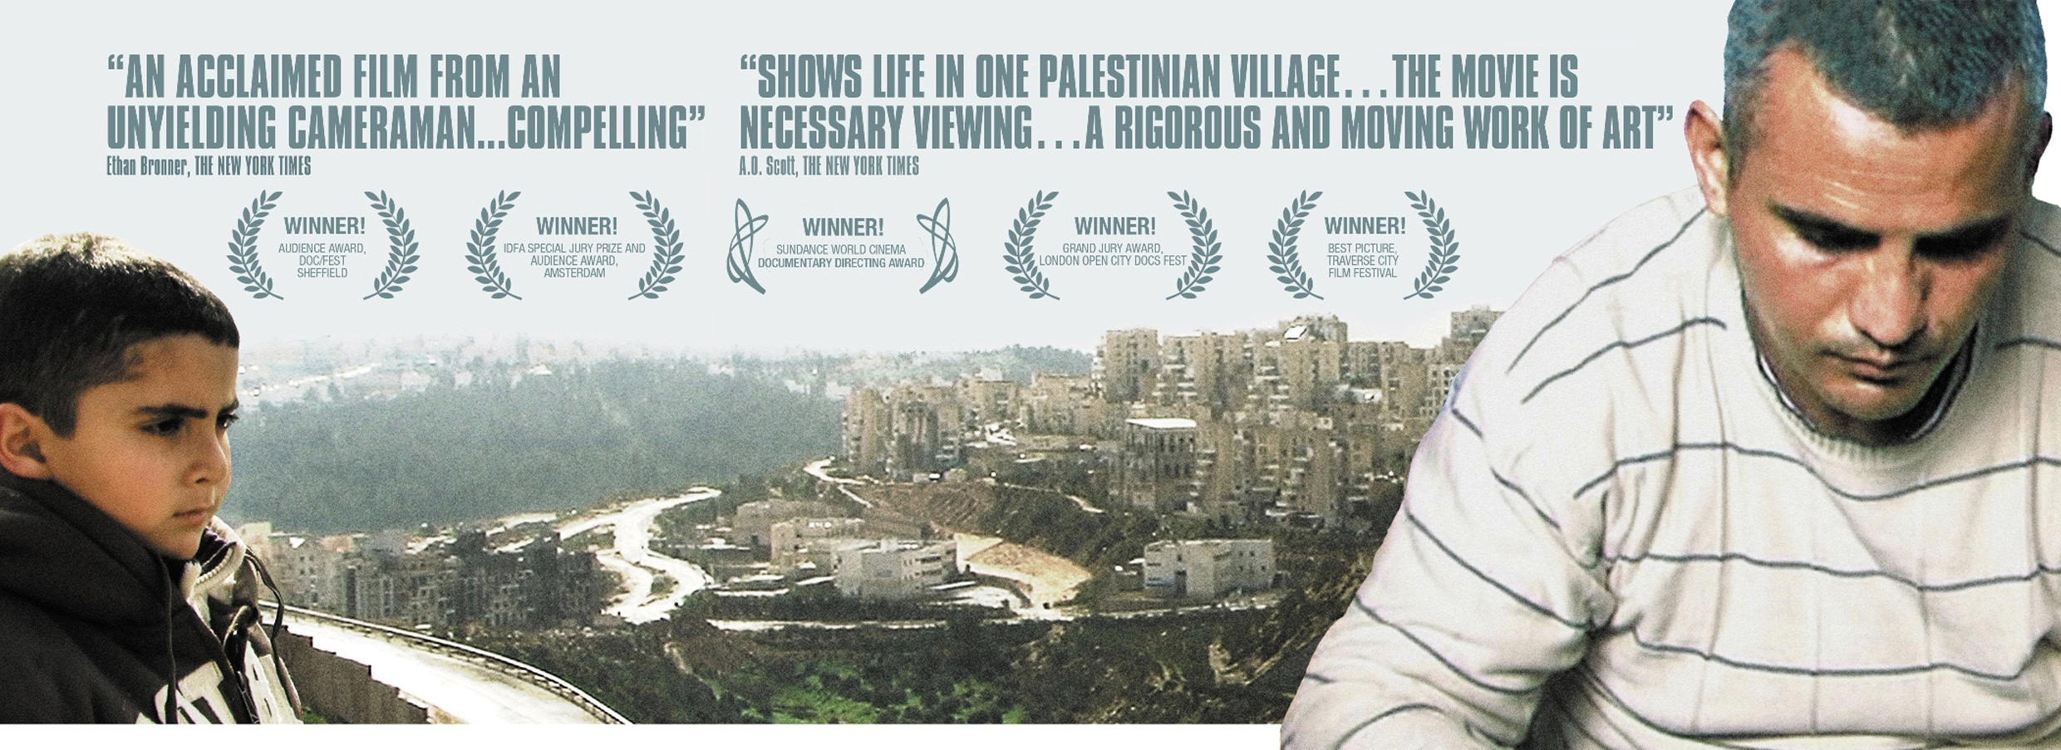5 Broken Cameras (Arabic: خمس كاميرات محطمة‎ Khamas Kamīrāt Muḥaṭṭamah;Hebrew: חמש מצלמות שבורות‎ Hamesh Matslemot Shvurot) is a documentary film co-directed by Palestinian Emad Burnat and Israeli Guy Davidi. 5 Broken Cameras is a first-hand account of protests in Bil'in, a West Bank village affected by the Israeli West Bank barrier. The documentary was shot almost entirely by Palestinian farmer Emad Burnat, who bought his first camera in 2005 to record the birth of his youngest son. In 2009 Israeli co-director Guy Davidi joined the project. Structured around the destruction of Burnat's cameras, the filmmakers' collaboration follows one family's evolution over five years of turmoil.

Is this film a Primary or Secondary source? ____________ Why?___________________________________________________
^{Camera #} | What do you see happening on the Palestinian POV?  How does their bias influence their actions? | What do you see happening from the Israeli POV? How does their bias influence their actions?
¹
²
^{Camera #} | What do you see happening on the Palestinian POV?  How does their bias influence their actions? | What do you see happening from the Israeli POV? How does their bias influence their actions?
³
⁴
⁵

How does one’s bias (geographical? Economic? Political?) influence their actions? Use both sides answer this question.

